Group

Database Development

**Course Work 1 - M26CDE**

**Group Members:**

Chris Rolling

Iskandar Mohd Supian

Thabiso Khumalo

Dumebi Jeffreys

Lecturer: Rachid Anane

**Group Members:**

Chris Rolling

Iskandar

Thabiso Khumalo

Dumebi Jeffreys

Table of Contents

Introduction 3

Importance of Data warehouse 6

Ensure consistency: 6

Make better business decisions: 7

Improve their bottom line: 7

The Rational for Data Warehouse 7

Conclusion: 8

Appendix 1 9

Table of Figures 9

Appendix 2 10

References 10

Data Warehouse

## Introduction

Data warehousing became necessary because of the enormous electronic data storage requirement and the urgency with which data outside the routine tasks was required for accomplishing goals. They are designed to provide important strategic information on every aspect of business operations; which when processed is used for achieving competitive business advantage (Van Beek 2017) (Ponniah 2010).

## .

#### Bottom of Form

#### What is a Data Warehouse?

A data warehouse is an engineered presentation of a system of information designed to grant operatives access to both current and achieved decision support information, that would otherwise be difficult to reach or present in standard operational systems. The main characteristics is the combined element that allows the extraction, transformation and the loading (ETL) solutions, elements of a data warehouse environment; an online analytical processing (OLAP) generator that has many applications with client analysis tools is used for managing the process of data gathering and delivery to business users. (Khachane 2013).

Data Warehouse Architecture

The principles Data warehouse architecture are:

* Data Sources
* Data Warehouses
* Data Marts
* Publication Services

Extraction, Transformation and Loading (ETL):

ETL process starts with the extraction of data, cleaning and subsequent arrangement before it is loaded into a data warehouse. This process has a critical role in data integration, it enhances the value of data. This primary process is the foundation of business intelligence and it determines the success or failure rate of any business intelligence project. It involves transferring data from source to a specific data warehouse; the ETL design always drive the maintainability, efficiency and flexibility of the loaded data. (Dhakal 2014)

There are three common architecture used in data warehouse albeit dependent on individual organization and their specific requirements. These are as follows:

1. Data Warehouse – Basic

The data warehouse basic presents the metadata and raw data of a classical OLTP system, with the addition of the summary data. These are found to be invaluable as long operations are pre-computed in advance within. An example: retrieving something such as June sales is a classic data warehouse query. This is presented in figure 1.

Figure 1 Data Warehouse Basic depiction (Oracle, 2017).

Figure 1 Data Warehouse – Basic (Oracle, 2017).

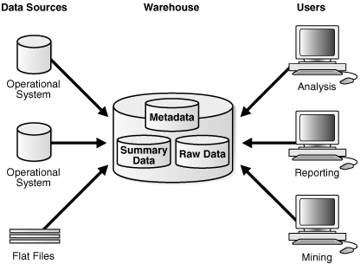

1. Data Warehouse - with Staging Area

Building summaries and general warehouse management are simplified in a staging area; such typical architecture is illustrated Figure 2. Operational data must be processed and cleaned before integration into the warehouse. Although most architecture has a staging area, this can also be programmed.

Figure 2 Architecture of a Data Warehouse with a Staging Area (Oracle, 2017).

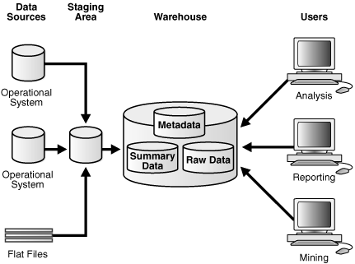

1. Data Warehouse – With Staging Area and Data Marts

This is a common architecture that can be customize according to the requirements of the warehouse's architecture with reference to different groups within an organization. A system designed for a given business line (Data marts) can be added separately. Purchasing, sales and inventories are good example; the analysisofhistorical purchases and mining historical data or sales may be carried out and results used to predict customer behaviour. Please see Figure 3 for illustration (*Oracle,* 2017).

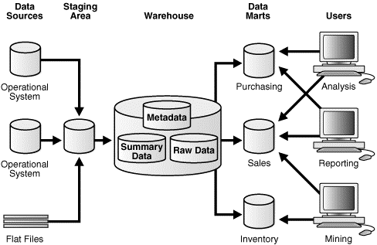

Figure 3 Architecture of a Data Warehouse with a Staging Area and Data Marts (Oracle, 2017).

# Importance of Data warehouse

Data warehousing is becoming one of the most important intelligence business tool, designed to allow the following for organizations:

### **Ensure consistency:**

A uniformed formation is applied to all collected data when programming data ware houses; creating an effortless analysis and global data share and insight among cooperate decisions makers. The rate of interpretation error is greatly reduced due to the standardization of data from different sources, with comprehensive improvement in accuracy.

### **Make better business decisions:**

Data-driven strategies based on facts are regularly used by successful business leaders for decision making. The speed and efficiency with which the different fact sets contained in the data are accessed is improved through data warehousing, also insights that can be modelled for marketing and business strategies which can distinguish them from the competitors can easily be derived by the co-operate decision makers.

### **Improve their bottom line:**

Business leaders can quickly access their organization's historical activities; both past successful and unsuccessful initiatives can be reviewed through data warehouse platform. Information on how strategies can be adjusted in line with current market trend, for increased sales, maximizing efficiency and bottom line improvement can be gleaned by the executives (Herzing University, 2017).

# The Rational for Data Warehouse

The need for Information for appropriate decision making by the executives responsible for keeping and managing an enterprise and the fact that the required information is essential for business strategy formulation, defining objectives and goal establishment created a real need for data warehousing. Executives and the manager need this information to make strategic business decisions with regards to their objectives; some of the uses of the data or information are as follows:

1. Gaining an in-depth knowledge of company’s operation
2. Monitoring and reviewing key performance indicators
3. To understand the relationship between the key performance indicators
4. Tracking business factor change over time
5. Monitor company performance in relation to competition and industry benchmarks.

Managers and executives need business strategic information which includes customer preferences, needs, product services and quality level; also, marketing, sales results and emerging technologies. These encompass the entire organisation and are required for business strategy formulation and execution; they are critical business decisions which are entirely dependent on proper strategic information in an enterprise (Ponniah 2010).

# **Conclusion:**

Data warehouse presents a great opportunity for businesses for monitoring, evaluating and analysing performance data across board. It is greatly important because of the ability to give insight into past operational performance; and the provision of data used in strategical operation decisions of Organisations. This ability creates a limitless opportunity for customisation and maximization of services, and improved operational advantage against competition; and ultimately improved bottom line. Data ware housing indeed is a welcome development.

# **Appendix 1**

# Table of Figures

Figure 1 Data Warehouse Basic depiction (Oracle, 2017). 4

Figure 2 Architecture of a Data Warehouse with a Staging Area (Oracle, 2017). 5

Figure 3 Architecture of a Data Warehouse with a Staging Area and Data Marts (Oracle, 2017). 5

# Appendix 2

# References

1. Dhakal, A. (2014) *Data Warehouse Architecture* [online] available from <https://www.datasciencecentral.com/profiles/blogs/data-warehouse-architecture> [7 November 2017]
2. Khachane, V. (2013) *DATA WAREHOUSE ARCHITCTURE AND DATA ANALYSIS TECHNIQUES* [online] 1st edn. Thane, Mumbai. available from <http://dspace.vpmthane.org:8080/jspui/bitstream/123456789/3171/1/Data%20Warehouse%20Architecture.pdf> [7 November 2017]
3. *Oracle*(2017) *Data Warehousing Concepts* [online] available from <https://docs.oracle.com/cd/E11882_01/server.112/e25554/concept.htm#DWHSG8073> [7 November 2017]
4. Ponniah, P. (2010). *Data Warehousing Fundamentals for IT Professionals*. Hoboken: John Wiley & Sons, Inc.
5. SAP. (2017). *Data Warehouse Solutions & Tools | EDW Technology | SAP*. [online] Available at: https://www.sap.com/uk/products/technology-platforms/data-warehousing.html?campaigncode=CRM-GB17-PPC-PPCDBCA&source=ppc-UK-DBDM-DBDM_Data_Warehousing-GOO&gclid=CIi387myw9cCFY7MGwod6iAPBA&gclsrc=ds [Accessed 16 Nov. 2017].
6. Van Vee k D. (2017) 9 *Reasons For A Data Warehouse* l *Discover All The DWH Benefits*[online] avaialable from <https://www.passioned.com/nine-reasons-to-build-a-data-warehouse/> [1 December 2017]
7. *What Is Data Warehousing And Why Is It Important?* (2017) available from <https://www.herzing.edu/blog/what-data-warehousing-and-why-it-important> [7 November 2017]